A
Real-Time Research Project On
DESIGNING THE HAPTIC INTERFACE SYSTEM FOR THE DISABLED INDIVIDUALS
(Submitted in partial fulfillment of the requirements for the award of Degree)

BACHELOR OF TECHNOLOGY
In

COMPUTER SCIENCE AND ENGINEERING
By

DEGALA RAMU (247R1A0579) MOHAMMAD ABBU (247R1A05A6)
G.SURYAPRAKASH (247R1A0585)

Under the Guidance of
Ms G SWATHI
(Assistant professor)


DEPARTMENT OF COMPUTER SCIENCE AND ENGINEERING
CMR TECHNICAL CAMPUS
UGC AUTONOMOUS
(Accredited by NAAC, NBA, Permanently Affiliated to JNTUH, Approved by AICTE, New Delhi)
Recognized Under Section 2(f) & 12(B) of the UGCAct.1956, Kandlakoya (V), Medchal Road, Hyderabad-501401.
April, 2026.

DEPARTMENT OF COMPUTER SCIENCE AND ENGINEERING


CERTIFICATE

This is to certify that the project entitled “DESIGNING THE HAPTIC INTERFACE SYSTEM FOR THE DISABLED INDIVIDUALS” being submitted by Degala Ramu (247R1A0579), Mohammad Abbu bakar (247R1A05A6) & G Suryaprakash (247R1A0585) in partial fulfillment of the requirements for the award of the degree of B.Tech in Computer Science and Engineering to the Jawaharlal Nehru Technological University Hyderabad, during the year 2025-26.

The results embodied in this thesis have not been submitted to any other University or Institute for the award of any degree or diploma.

Ms. G. Swathi Dr. Nuthanakanti Bhaskar Assisstant Professor HoD
INTERNAL GUIDE

ACKNOWLEDGEMENT
We take this opportunity to express our gratitude to the people who have been instrumental in the successful completion of this project, we take this opportunity to express our profound gratitude and deep regard to our guide G. Swathi, Assistant Professor for her exemplary guidance, monitoring and constant encouragement throughout the project work. The blessing, help and guidance given by her shall carry us a long way in the journey of life on which we are about to embark.

We take this opportunity to extend our heartfelt appreciation to the Project Review Committee (PRC) Coordinators—Dr. J. Narasimharao, Ms. G. Swathi, Mr. G. Pavan Kumar and Mrs. A. Divya Bharathi —for their unwavering support, insightful guidance, and valuable inputs, which played a crucial role in steering this project through its various stages.

Our sincere appreciation also goes to Dr. Nuthanakanti Bhaskar, Head, for his encouragement and continuous support in ensuring the successful completion of our project.
We are deeply grateful to Dr. A. Raji Reddy, Director, for his cooperation throughout the course of this project. Additionally, we extend our profound gratitude to Sri. Ch. Gopal Reddy, Chairman, Smt. C. Vasantha Latha, Secretary and Sri. C. Abhinav Reddy, Vice-Chairman, for fostering an excellent infrastructure and a conducive learning environment that greatly contributed to our progress.

We also acknowledge and appreciate the guidance and assistance provided by the faculty and staff of CMR Technical Campus, whose contributions have been invaluable in bringing this project to fruition.
Lastly, we sincerely thank our families for their unwavering support and encouragement. We also extend our gratitude to the teaching and non-teaching staff of CMR Technical Campus for their guidance and assistance. Their contributions, along with the support of everyone who helped directly or indirectly, have been invaluable in the successful completion of this project.

Degala. Ramu (247R1A0579)
Mohammad. Abbu (247R1A05A6)
G. Suryaprakash (247R1A0585)

VISION AND MISSION

INSTITUTE VISION:
To Impart quality education in serene atmosphere thus strive for excellence in Technology and Research.

INSTITUTE MISSION:
- To create state of art facilities for effective Teaching- Learning Process.

- Pursue and Disseminate Knowledge based research to meet the needs of Industry & Society.

- Infuse Professional, Ethical and Societal values among Learning Community.

DEPARTMENT VISION:
To provide quality education and a conducive learning environment in computer engineering that foster critical thinking, creativity, and practical problem-solving skills.

DEPARTMENT MISSION:
- To educate the students in fundamental principles of computing and induce the skills needed to solve practical problems.

- To provide State-of-the-art computing laboratory facilities to promote
industry institute interaction to enhance student’s practical knowledge.

- To inculcate self-learning abilities, team spirit, and professional ethics among the students to serve society.

ABSTRACT

The Haptic Interface System is a user-centered assistive technology designed to address the significant challenges faced by individuals with visual, auditory, or motor impairments when navigating physical and digital environments. Conventional interfaces rely heavily on visual and auditory cues, which often create barriers to independence and safety for disabled users. This project bridges these sensory gaps by leveraging the sense of touch—specifically tactile and force feedback—as a primary communication channel to convey critical spatial and environmental information.
The proposed system is built on an embedded IoT framework, utilizing a compact and lightweight wearable form factor, such as a glove or armband, to ensure user comfort and portability. At its core, the system employs high-performance microcontrollers like the ESP32 (Node MCU) or Arduino Nano to ensure low-latency, real-time processing of environmental data. The sensory suite includes:
- Ultrasonic "ECHO" Sensors: These provide precise, non-contact distance measurements ranging from 2cm to 4 meters. The system calculates distance by measuring the pulse width of returning ultrasonic waves, allowing for stable obstacle detection.
- IMU Sensors (Accelerometers and Gyroscopes): These monitor motion and enable gesture recognition, allowing for more interactive and intuitive control.
Unlike existing solutions—such as the "Buzzard Cane" or simple buzzers that offer only binary proximity warnings—this system features a multi-actuator haptic array consisting of 8 to 12 vibration motors. This array provides nuanced, directional feedback where vibration intensity corresponds to the proximity of an object, effectively guiding the user through complex surroundings while reducing cognitive load.
Designed for daily practical use, the interface emphasizes affordability and energy efficiency, maintaining an average power consumption of less than 50mW. It is optimized to run on portable power sources, such as 9V Hi-Watt or 1.5V batteries, and includes voltage regulators (LM7805) to ensure stable operation. Furthermore, the system is scalable and customizable; it integrates Bluetooth connectivity for smartphone augmentation, allowing for machine learning-based adaptation to a user's specific preferences via a companion app. By providing real-time tactile cues for navigation and object recognition, this haptic interface significantly enhances the independence, safety, and overall quality of life for disabled individuals.

LIST OF FIGURES

FIGURE NO FIGURE NAME PAGE NO

Figure 3.1

Figure 5.1

Block diagram 10

Connecting to the server 28
Figure 5.2

Connecting the transmitter 29

Figure 5.3

Connecting the receiver 29

Figure 5.4

For Data Search in projectfactoryserver.in 30

Figure 5.5 Display the data in the server 30

 | LIST OF TABLES
TABLE NO | TABLE NAME | PAGE NO
Table 6.2 | Test Cases | 33

TABLE OF CONTENTS

ABSTRACT i
LIST OF FIGURES ii
LIST OF TABLES iii
- INTRODUCTION 1
  - PROJECT PURPOSE 1
  - PROJECT FEATURES 1
- LITERATURE SURVEY 2
  - REVIEW OF RELATED WORK 4
  - DEFINITION OF PROBLEM STATEMENT 5
  - EXISTING SYSTEM 5
  - PROPOSED SYSTEM 6
  - OBJECTIVES 6
  - HARDWARE & SOFTWARE REQUIREMENTS 7
    - HARDWARE REQUIREMENTS 7
    - SOFTWARE REQUIREMENTS 7
- SYSTEM ARCHITECTURE & DESIGN 8
  - PROJECT ARCHITECTURE 9
  - DESCRIPTION 11
  - DATA FLOW DIAGRAM 13
- IMPLEMENTATION 16
  - ALGORITHMS USED 17
  - SAMPLE CODE 19
- RESULTS & DISCUSSION 27
- VALIDATION 31
  - INTRODUCTION 32
  - TEST CASES 33
- CONCLUSION & FUTURE ASPECTS 34
  - PROJECT CONCLUSION 35
  - FUTURE ASPECTS 36
- BIBLIOGRAPHY 37
  - REFERENCES 38
  - GITHUB LINK 39

1.INTRODUCTION

INTRODUCTION

Designing the Haptic Interface System for disabled individuals aims to bridge the gap between human–computer interaction and accessibility by leveraging the sense of touch as a primary communication channel. Individuals with visual, auditory, or motor impairments frequently encounter significant barriers when interacting with conventional interfaces that rely almost exclusively on visual or auditory feedback. By providing an alternative mode of interaction through vibration, pressure, and force feedback, haptic systems enable users to perceive and respond to the surroundings more effectively.
The motivation for this project stems from the limitations of current assistive technologies. Many existing solutions are expensive, bulky, or designed for a narrow range of disabilities, which limits their accessibility. Furthermore, traditional devices like the "Buzzard Cane" or simple wearable buzzers often provide only binary proximity warnings, failing to deliver the nuanced information—such as precise direction, distance, or texture—required for safe and independent navigation. These technical shortcomings can lead to user fatigue and a high dependency on external assistance.

PROJECT PURPOSE

The primary purpose of the Haptic Interface System is to enhance the accessibility, independence, and quality of life for individuals with visual, auditory, or motor impairments by enabling action with both digital and physical environments,. By leveraging the sense of touch as powerful communication channel, the project seeks to bridge the gap between traditional human-computer interaction and inclusive design.

PROJECT FEATURES
- Wearable haptic interface designed as a glove or armband
- Real-time obstacle detection using ultrasonic sensors
- Direction-based feedback using multiple vibration motors
- Distance-based intensity modulation of vibration patterns

LITERATURE SURVEY

LITERATURE SURVEY

1. Haptic Interfaces for Visually Impaired Users: A Review

Authors:MandayamA.Srinivasan,KatherineJ.Kuchenbecker
Description:
This paper provides a comprehensive review of haptic interface technologies developed to assist visually impaired individuals. It discusses tactile feedback mechanisms, force-feedback devices, and vibrotactile systems that enable users to perceive spatial and environmental information through touch. The study highlights design challenges, usability issues, and future research directions in assistive haptic systems.
2. Design of Wearable Haptic Systems for Assistive Applications
Authors:LynetteA.Jones,StephenJ.Lederman
Description:
The authors explore wearable haptic devices aimed at supporting individuals with sensory and motor disabilities. The paper focuses on lightweight, low-power wearable interfaces that provide tactile cues for navigation and object recognition. It emphasizes human-centered design principles and evaluates the effectiveness of tactile feedback in real-world assistive scenarios.

3. Vibrotactile Feedback Systems for Navigation Assistance in Disabled Individuals
Authors:HiroshiTanaka,KenjiSuzuki
Description:
This study proposes a vibrotactile feedback-based navigation system designed for individuals with visual and mobility impairments. The system uses vibration patterns to convey directional and obstacle-related information. Experimental results demonstrate improved navigation accuracy and reduced cognitive load for users.

REVIEW OF RELATED WORK

The development of haptic interface systems for disabled individuals has evolved significantly over past three decades, driven by advancements in sensor technologies, embedded systems, and human–computer interaction research. Researchers across disciplines including robotics, biomedical engineering, rehabilitation science, and assistive technology have explored the use of tactile and feedback as alternative communication channels. This section provides a comprehensive review of relevant research contributions, existing assistive technologies, and the limitations that motivate the proposed system.

Foundations of Haptic Technology in Assistive Systems
Haptic technology refers to the use of tactile and force-based feedback to convey information to users. Early foundational research in haptics demonstrated that the human skin is highly sensitive to variations in vibration frequency, amplitude, and spatial distribution. Studies conducted by researchers such as Mandayam Srinivasan established the scientific understanding of tactile perception and force feedback mechanisms. His work emphasized the importance of designing haptic systems that align with the physiological characteristics of the human sensory system. Similarly, research contributions by Katherine Kuchenbecker explored the rendering of realistic tactile sensations through actuators and vibrotactile devices. These studies demonstrated that properly designed vibration patterns could effectively communicate environmental properties such as texture, stiffness, and spatial orientation. Such research laid the foundation for modern wearable haptic systems. These foundational works highlighted two important principles:
Vibrotactile Navigation Systems for Visually Impaired Users
One of the most widely researched applications of haptics is navigation assistance for visually impaired individuals. Several wearable systems have been proposed to provide obstacle detection and directional guidance through vibration cues.Early vibrotactile belts were designed to provide directional awareness using multiple motors placed around the waist. When an obstacle was detected, the motor corresponding to the obstacle’s direction would vibrate. Studies demonstrated that users were able to interpret directional cues with minimal training. However, these systems were often bulky and power-intensive .Research on ultrasonic-based navigation devices revealed that converting distance information vibration intensity allows users to estimate proximity more accurately. For example, closer obstacles
were represented by stronger vibrations, while distant obstacles produced weaker signals. Experimental evaluations showed improved navigation accuracy and reduced collision rates compared to audio-based systems.

2.2 DEFINITION OF PROBLEM STATEMENT
Disabled individuals face persistent challenges in interacting with their physical environment and digital systems due to the reliance of conventional interfaces on visual and auditory feedback. Existing assistive technologies often provide limited tactile feedback, lack real-time responsiveness, and are not adaptable to diverse user needs. Many solutions are expensive, bulky, and designed for specific disabilities, making them inaccessible to a broader population.
There is a critical need for an inclusive, wearable haptic interface system that provides accurate and real-time tactile feedback to support navigation, object interaction, and human–computer interaction. The system should be affordable, energy-efficient, comfortable to wear, and customizable to individual user preferences. Addressing these challenges will enhance independence, safety, and quality of life for disabled individuals

2.3 EXISTING SYSTEM
Current assistive systems for disabled individuals primarily rely on audio-based navigation aids and basic vibration alerts. Smartphone applications provide voice guidance and camera-based object recognition, but they require continuous auditory attention, which can be distracting and ineffective in noisy environments. Some wearable devices provide proximity alerts using single vibration motors; however, these systems lack directional feedback and do not convey precise distance information. Existing haptic devices are often expensive and battery-intensive, limiting their accessibility in resource-constrained settings. Additionally, many systems are designed for a specific category of disability and do not accommodate diverse user needs. The lack of customization and adaptability reduces user acceptance and long-term usability.

Limitations of Existing System

Existing assistive systems for disabled individuals, particularly those based on basic haptic or audio feedback mechanisms, suffer from multiple significant limitations that restrict their practical usability and widespread adoption. Many currently available solutions rely heavily on audio-based guidance, which becomes ineffective in noisy environments and is unsuitable for hearing-impaired users, while also increasing cognitive load due to continuous auditory processing. Several wearable haptic devices provide only binary vibration alerts (on/off) without conveying precise directional or distance information, making it difficult for users to accurately interpret obstacle location and urgency. In addition, most systems use a limited number of vibration motors, resulting in poor spatial mapping and reduced situational awareness. Commercial assistive devices are often expensive due to proprietary hardware and complex designs, making them inaccessible to users in low-income or developing regions.

PROPOSED SYSTEM
The proposed haptic interface system is designed as a wearable device that integrates ultrasonic sensors, IMU sensors, and a microcontroller to provide real-time tactile feedback. The ultrasonic sensor measures the distance to nearby obstacles, while the IMU tracks hand orientation and movement. The microcontroller processes this data and activates multiple vibration motors arranged in an array to convey directional and distance-based information. Bluetooth connectivity enables the system to connect to a smartphone application, allowing users to configure sensitivity levels, vibration patterns, and alert thresholds. The system is designed to be energy-efficient and lightweight, ensuring comfort during prolonged use. The modular architecture allows additional sensors and features to be integrated in the future.

Advantages of the Proposed System:

Real-Time Directional Feedback:
The system provides multi-directional vibration alerts with distance-based intensity, allowing users to easily identify the location and proximity of obstacles.
Wearable and Lightweight Design: The compact and ergonomic structure ensures comfort for long-term use and improves user acceptance in daily activities.
Customizable and User-Friendly: Bluetooth connectivity enables users to adjust sensitivity levels and vibration patterns according to their personal needs.
Cost-Effective and Energy-Efficient: The use of affordable components and optimized power consumption makes the system accessible and suitable for extended usage.

2.5 OBJECTIVES
To design an inclusive haptic interface for disabled individuals
To provide real-time tactile feedback for navigation and interaction
To reduce dependency on visual and auditory interfaces
To improve safety and confidence during mobility
To develop a low-cost and energy-efficient wearable device
To enable user customization of feedback patterns
To provide a scalable platform for future enhancement

2.6 HARDWARE & SOFTWARE REQUIREMENTS

2.6.1 HARDWARE REQUIREMENTS:
Node MCU / ESP32 Microcontroller
Ultrasonic Distance Sensor
Inertial Measurement Unit (IMU)
Vibration Motors (Multiple)
Bluetooth Module
Rechargeable Battery
Voltage Regulator Circuit
Wearable Enclosure (Glove/Armband)

2.6.2 SOFTWARE REQUIREMENTS:
Arduino IDE
Embedded C / Arduino Programming Language
Serial Monitor for Debugging
Mobile Application for Configuration
Firmware Libraries for Sensors and Bluetooth

3. SYSTEM ARCHITECTURE

& DESIGN

SYSTEM ARCHITECTURE & DESIGN
The System Architecture of the proposed Haptic Interface System for Disabled Individuals describes how the different hardware components interact to provide assistive functionality. The system is divided into two main sections: the Transmitter (TX) unit and the Receiver (RX) unit. These units communicate with each other using wireless communication through the ESP8266 microcontroller. The architecture is designed to ensure real-time processing of sensor data and quick delivery of tactile feedback to the user. In the transmitter section, sensors such as the Ultrasonic sensor and R.P.S (Reference Position System) collect environmental and location data. A push button is also included for manual input or emergency activation. All these inputs are processed by the ESP8266 microcontroller, which acts as the central processing unit of the system. The processed data is then transmitted to external modules such as GPS for location tracking and mobile devices for monitoring and configuration. The receiver section receives the transmitted signals and converts them into alerts using output devices such as a buzzer and vibration motor, allowing the user to perceive environmental information through tactile and sound feedback.

PROJECT ARCHITECTURE
The project architecture consists of interconnected hardware modules that work together to detect obstacles, process information, and provide feedback to the user. The architecture is mainly composed of input devices, a processing unit, communication modules, and output devices. The input devices include the ultrasonic sensor and R.P.S module, which gather environmental and positional information. The ultrasonic sensor measures the distance between the user and nearby obstacles, while the R.P.S module helps in identifying the user's position. A push button is used for manual control or emergency. These inputs are sent to the ESP8266 microcontroller, which processes the data and determines the appropriate response. After processing, the information is transmitted to the receiver module, where output components such as a buzzer and vibration motor generate alerts. The vibration motor provides haptic feedback that helps the user understand the presence and proximity of obstacles through touch. At the same time, GPS and mobile connectivity allow location tracking and system monitoring. This architecture ensures that the system operates efficiently and provides timely feedback to assist disabled individuals in navigating their surroundings safely.

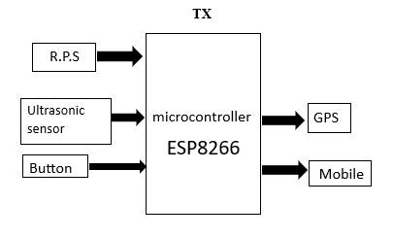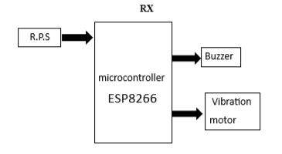

Figure 3.1 : block diagram

DESCRIPTION

The proposed Haptic Interface System for Disabled Individuals is designed using a structured embedded system methodology that clearly separates system functionality from implementation architecture. This separation ensures efficient hardware–software co-design, reduced integration complexity, and improved reliability.
The system architecture consists of interconnected subsystems: sensing, processing, actuation, communication, and power management. The sensing subsystem collects environmental data using proximity, motion, or navigation sensors. These sensors convert physical parameters such as distance, movement, or orientation into electrical signals. The collected signals are conditioned and forwarded to the processing unit.
The processing and control subsystem forms the core of the system. A microcontroller performs real-time data acquisition, filtering, and decision-making. Based on predefined algorithms, the controller maps environmental information to suitable haptic patterns. Time-critical operations such as pulse-width modulation for vibration control are handled using hardware timers, while decision logic and adaptive are implemented in software. This represents effective hardware–software partitioning.
The haptic actuation subsystem translates digital control signals into tactile feedback through vibration motors or linear resonant actuators. Different vibration intensities, frequencies, and patterns convey specific information such as obstacle proximity or navigation direction. Low-latency response and consistent feedback strength are essential design considerations.
The communication subsystem enables wireless interaction with external devices such as smartphones. It allows configuration, calibration, firmware updates, and customization of feedback patterns. Communication tasks operate concurrently with sensing and actuation processes, ensuring uninterrupted real-time performance.
The power management subsystem ensures energy efficiency and long operational life. It includes battery regulation, monitoring circuits, and sleep-mode control strategies. Power-saving mechanisms such as duty cycling and event-driven activation reduce unnecessary energy consumption.
From a design methodology perspective, the development process follows four major stages: specification, system synthesis, implementation synthesis, and performance evaluation. During specification, functional and non-functional requirements are defined. In system synthesis, hardware and software responsibilities are partitioned while considering concurrency and timing constraints. Implementation synthesis involves firmware development, circuit design, and integration. Finally, performance evaluation validates functional accuracy, timing, and power consumption. Concurrency is treated as a fundamental design principle. Sensor acquisition, processing, communication, and actuation operate in parallel through interrupt-driven execution or real-time scheduling. Formal models such as state machines can be used to define system behavior, while simulation tools assist in validating timing and functional correctness before deployment. Overall, the architecture ensures real-time responsiveness, modularity, scalability, and reliability. By integrating embedded system design principles with user-centered considerations, the proposed haptic interface system achieves efficient operation while maintaining accessibility, adaptability, and ease of use for disabled individuals.

3.3 DATA FLOW DIAGRAM

The Data Flow Diagram (DFD) represents how data moves through the Haptic Interface System, showing the interaction between external entities, processes, data stores, and outputs. It focuses on the logical flow of information rather than hardware implementation.
Level 0 DFD (Context Diagram)
At the highest level, the entire system is represented as a single process.
External Entities:
User (Disabled Individual)
Environment
Mobile Application / Caregiver
Main Process:
Haptic Interface System

Data Flow:
Environment → Distance/Obstacle Data → Haptic Interface System
User → Control Inputs/Mode Selection → Haptic Interface System
Haptic Interface System → Tactile Feedback → User
Mobile App → Configuration Settings → Haptic Interface System
Haptic Interface System → Status/Battery Data → Mobile App
This level shows the system as a black box interacting with external entities.
Level 1 DFD (Detailed View)
The system is divided into major internal processes.

1. Process: Sensor Data Acquisition
Input: Raw signals from ultrasonic, IR, motion sensors
Output: Digital sensor data

2. Process: Data Processing & Decision Logic
Input: Sensor data
Processing:
Filtering and noise removal
Distance calculation
Threshold comparison
Output: Interpreted environmental information
3. Process: Haptic Pattern Generator
Input: Processed data
Processing:
Map distance to vibration intensity
Select appropriate vibration pattern
Output: Control signals for actuators

4. Process: Communication & Configuration
Input: User settings from mobile app
Processing:
Update system parameters
Store preferences
Output: Updated configuration

5. Process: Power Management
Input: Battery status
Processing:
Monitor voltage
Trigger low-battery alert
Output: Power control signals

Data Stores
D1: User Configuration Data
D2: Sensor Calibration Data
D3: System Logs / Status Information

Textual Representation of DFD
Environment
↓
[Sensor Data Acquisition]
↓
[Data Processing & Decision Logic]
↓
[Haptic Pattern Generator]
↓
User (Tactile Feedback)
Mobile App ↔ [Communication & Configuration] ↔ User Configuration Data
Power Unit → [Power Management] → System Controller

.IMPLEMENTATION

IMPLEMENTATION
The implementation of the Haptic Interface System for Disabled Individuals is carried out by integrating hardware components with embedded software based on the system architecture and hardware–software co-design principles. The goal of implementation is to translate the system specification into a working prototype that meets real-time, reliability, and power-efficiency requirements.

4.1 ALGORITHMS USED
1.Sensor Data Acquisition
Read sensor signals (ultrasonic/IR/accelerometer).
Apply noise filtering.
Send data to processing module.
2.Distance Calculation & Thresholding
Convert sensor signals to distance.
Compare with preset thresholds (near, medium, far).
Forward results to haptic module.
3.Haptic Pattern Generation
Map distance or event to vibration intensity and pattern.
Generate PWM signals for actuators.
Convey alerts or navigation cues to user.
4.Navigation Guidance
Compare current position with target.
Determine direction (forward, left, right).
Activate corresponding haptic feedback.

4.Power Management
Monitor battery voltage.
Reduce non-critical tasks in low-power mode.
Send low-battery alerts to user.
5.Finite State Machine (FSM) Control
Manage system states: Idle → Sensing → Processing → Alerting → Sleep.
State transitions triggered by sensors, user input, or timers.
These algorithms ensure real-time, reliable, and adaptive haptic feedback for disabled users while optimizing energy consumption.
Advantages

1.Enhanced Accessibility
Enables disabled individuals to perceive their environment through touch.
Reduces reliance on visual or auditory cues.
2.Real-Time Feedback
Immediate haptic responses for obstacle detection and navigation.
3.Customizable & Adaptive
Feedback intensity and patterns can be tailored to individual needs.
4.Portability & Wearable
Compact and lightweight design suitable for daily use.
5.Energy Efficient
Low-power modes and duty cycling extend battery life.

4.2 SAMPLE CODE

#include <LiquidCrystal.h>

#include <stdio.h>

//LiquidCrystal lcd(6, 7, 5, 4, 3, 2);

LiquidCrystal lcd(13, 12, 14, 27, 26, 25);

#include <WiFi.h>

#include <HTTPClient.h>

HTTPClient http;

const char *ssid = "iotserver";

const char *password = "iotserver123";

int httpResponseCode;

String servername = "http://projectsfactoryserver.in/storedata.php?name=";

String accountname = "iot1695";

String field1 = "&lat=";

String field2 = "&lan=";

String field3 = "&s1=";

String field4 = "&s2=";

String field5 = "&s3=";

String field6 = "&s4=";

String payload="";

int buzzer = 23;

int relay = 22;

int rf1 = 21;

int rf2 = 19;

float tempc=0,humc=0;

unsigned char rcv,count,gchr,gchr1,robos='s';

String status_string="";

int sti=0;

String inputString = ""; // a string to hold incoming data

boolean stringComplete = false; // whether the string is complete

#define RXD2 16

#define TXD2 17

int i=0,k=0,lop=0;

int gps_status=0;

float latitude=0;

float logitude=0;

String Speed="";

String gpsString="";

char *test="$GPRMC";

//int hbtc=0,hbtc1=0,rtrl=0;

unsigned char gv=0,msg1[10],msg2[11];

float lati=0,longi=0;

unsigned int lati1=0,longi1=0;

unsigned char flat[5],flong[5];

char finallat[10]="17.5971\0",finallong[10]="078.4864\0";

String finallat1="";

String finallong1="";

void iot_send()

{

lcd.setCursor(15,1);lcd.write('U');

http.begin(servername + accountname + field1 + finallat1 + field2 + finallong1 + field3 + status_string);

httpResponseCode = http.GET();

if(httpResponseCode>0)

{

payload="";

//Serial.print("HTTP Response code: ");

//Serial.println(httpResponseCode);

payload = http.getString();

//Serial.println(payload);

}

else

{

;

//Serial.print("Error code: ");

//Serial.println(httpResponseCode);

}

delay(8000);

//lcd.setCursor(0,1);lcd.print("Emergency ");

lcd.setCursor(15,1);lcd.write(' ');

}

void beep()

{

digitalWrite(buzzer, LOW);delay(2000);digitalWrite(buzzer, HIGH);

}

void okcheck()

{

unsigned char rcr;

do{

rcr = Serial.read();

}while(rcr != 'K');

}

void setup()

{

Serial.begin(9600);//serialEvent();

Serial2.begin(9600, SERIAL_8N1, RXD2, TXD2);

pinMode(rf1, INPUT);pinMode(rf2, INPUT);

pinMode(relay, OUTPUT);pinMode(buzzer, OUTPUT);

digitalWrite(relay, LOW);digitalWrite(buzzer, HIGH);

lcd.begin(16, 2);

lcd.print("Design Haptic");

lcd.setCursor(0,1);

lcd.print("Disbaled Individual");

delay(2500);

WiFi.begin(ssid, password);

Serial.println("Connecting");

while(WiFi.status() != WL_CONNECTED)

{

delay(500);

}

//Serial.println(WiFi.localIP());

delay(3000);

lcd.clear();lcd.print("Getting GPS.....");delay(2000);

//get_gps();

//gps_convert();

lcd.clear();

lcd.setCursor(0,0);

for(ii=0;ii<=6;ii++) lcd.write(finallat[ii]);

lcd.setCursor(0,1);

for(ii=0;ii<=7;ii++) lcd.write(finallong[ii]);

finallat[7] = '\0';

finallong[8] ='\0';

finallat1="";

finallong1="";

finallat1 = String(finallat);

finallong1 = String(finallong);

delay(3000);

lcd.clear();

}

int sts1=0,sts2=0,cntlmk=0;

int stn=0;

int hbv=0;

char eyes='c';

int eye_flag=0;

void loop()

{

if(digitalRead(rf1) == LOW || digitalRead(rf2) == LOW)

{

lcd.setCursor(0,0);lcd.print("Vib ON ");

status_string="";

if(digitalRead(rf1) == LOW)

{

status_string="Obstacle"; digitalWrite(relay, HIGH);

}

if(digitalRead(rf2) == LOW)

{

status_string="Panic"; digitalWrite(relay, HIGH);

}

beep();

iot_send();

}

if(digitalRead(rf1) == HIGH && digitalRead(rf2) == HIGH)

{

lcd.setCursor(0,0);lcd.print("Normal ");digitalWrite(relay, LOW);

}

}

void serialEvent()

{

while (Serial.available())

{

char inChar = (char)Serial.read();

if(inChar == '*')

gpsString="";

while(1)

{

//while (gps.available()>0) //Serial incoming data from GPS

while (Serial.available() > 0)

{

//char inChar = (char)gps.read();

char inChar = (char)Serial.read();

gpsString+= inChar; //store incoming data from GPS to temparary string str[]

i++;

// Serial.print(inChar);

if (i < 7)

{

if(gpsString[i-1] != test[i-1]) //check for right string

{

i=0;

gpsString="";

}

}

if(inChar=='\r')

{

if(i>60)

{

gps_status=1;

break;

}

else

{

i=0;

}

}

}

if(gps_status)

break;

}

}

void get_gps()

{

lcd.clear();

lcd.print("Getting GPS Data");

lcd.setCursor(0,1);

lcd.print("Please Wait.....");

gps_status=0;

int x=0;

while(gps_status==0)

{

gpsEvent();

int str_lenth=i;

coordinate2dec();

i=0;x=0;

str_lenth=0;

}

}

void coordinate2dec()

{

String lat_degree="";

for(i=17;i<=18;i++)

lat_degree+=gpsString[i];

String lat_minut="";

for(i=18;i<=19;i++)

lat_minut+=gpsString[i];

for(i=21;i<=22;i++)

lat_minut+=gpsString[i];

String log_degree="";

for(i=29;i<=31;i++)

log_degree+=gpsString[i];

String log_minut="";

for(i=32;i<=33;i++)

log_minut+=gpsString[i];

for(i=35;i<=36;i++)

log_minut+=gpsString[i];

Speed="";

for(i=42;i<45;i++) //extract longitude from string

Speed+=gpsString[i];

float minut= lat_minut.toFloat();

minut=minut/60;

float degree=lat_degree.toFloat();

latitude=degree+minut;

minut= log_minut.toFloat();

minut=minut/60;

degree=log_degree.toFloat();

logitude=degree+minut;

}

void gps_convert()

{

if(gps_status)

{

// Serial.println(gpsString);

if(gpsString[0] == '$' && gpsString[1] == 'G' && gpsString[2] == 'P' && gpsString[3] == 'R' && gpsString[4] == 'M' && gpsString[5] == 'C')

{

// Serial.println("Don11111111111111111111111111111111111111111111111111111\r\n");

// Serial.write(gpsString[18]);Serial.write(gpsString[19]);Serial.write(gpsString[20]);Serial.write(gpsString[21]);Serial.write(gpsString[22]);

//lcd.setCursor(0,0);

for(ii=0;ii<9;ii++)

{

//lcd.write(gpsString[19+ii]);

msg1[ii] = gpsString[19+ii];

//Serial.write(msg1[ii]);

}

//Serial.println("\r\n");

//lcd.setCursor(0,1);

for(ii=0;ii<10;ii++)

{

//lcd.write(gpsString[32+ii]);

msg2[ii] = gpsString[32+ii];

// Serial.write(msg2[ii]);

}

// Serial.println(msg1);

// Serial.println(msg2);

//lati = (((msg1[2]-48)*100000) +((msg1[3]-48)*10000) + ((msg1[5]-48)*1000) + ((msg1[6]-48)*100) + ((msg1[7]-48)*10) + (msg1[8]-48));

//longi = (((msg2[3]-48)*100000) + ((msg2[4]-48)*10000) + ((msg2[6]-48)*1000) + ((msg2[7]-48)*100) + ((msg2[8]-48)*10) + (msg2[9]-48));

lati = (((msg1[2]-48)*1000) + ((msg1[3]-48)*100) + ((msg1[5]-48)*10) + (msg1[6]-48));

longi = (((msg2[3]-48)*1000) + ((msg2[4]-48)*100) + ((msg2[6]-48)*10) + (msg2[7]-48));

// converts(lati);Serial.write("-");

// converts(longi);Serial.write("\r\n");

lati = (lati/60); longi = (longi/60);

lati = (lati*100); longi = (longi*100);

lati1 = lati; longi1 = longi;

// Serial.write("After ");

// converts(lati1);Serial.write("-");

// converts(longi1);Serial.write("\r\n");

convlat(lati); convlong(longi);

finallat[0] = msg1[0];

finallat[1] = msg1[1];

finallat[2] = '.';

finallat[3] = flat[0]; finallat[4] = flat[1];finallat[5] = flat[2];finallat[6] = flat[3];finallat[7] = '\0';

finallong[0] = msg2[0];

finallong[1] = msg2[1];

finallong[2] = msg2[2];

finallong[3] = '.';

finallong[4] = flong[0];finallong[5] = flong[1];finallong[6] = flong[2];finallong[7] = flong[3];finallong[8] = '\0';

}

}

}

void convlat(unsigned int value)

{

unsigned int a,b,c,d,e,f,g,h;

a=value/10000;

b=value%10000;

c=b/1000;

d=b%1000;

e=d/100;

f=d%100;

g=f/10;

h=f%10;

a=a|0x30;

c=c|0x30;

e=e|0x30;

g=g|0x30;

h=h|0x30;

// dlcd(a);

// dlcd(c);dlcd(e); dlcd(g);dlcd(h);//lcddata('A');//lcddata(' ');lcddata(' ');

flat[0] = c;

flat[1] = e;

flat[2] = g;

flat[3] = h;

}

void convlong(unsigned int value)

{

unsigned int a,b,c,d,e,f,g,h;

a=value/10000;

b=value%10000;

c=b/1000;

d=b%1000;

e=d/100;

f=d%100;

g=f/10;

h=f%10;

a=a|0x30;

c=c|0x30;

e=e|0x30;

g=g|0x30;

h=h|0x30;

// dlcd(a);

// dlcd(c);dlcd(e); dlcd(g);dlcd(h);//lcddata('A');//lcddata(' ');lcddata(' ');

flong[0] = c;

flong[1] = e;

flong[2] = g;

flong[3] = h;

}

void converts(unsigned int value)

{

unsigned int a,b,c,d,e,f,g,h;

a=value/10000;

b=value%10000;

c=b/1000;

d=b%1000;

e=d/100;

f=d%100;

g=f/10;

h=f%10;

a=a|0x30;

c=c|0x30;

e=e|0x30;

g=g|0x30;

h=h|0x30;

Seril.write(a);

Serial.write(c);

Serial.write(e);

Serial.write(g);

Serial.write(h);

}

void convertl(unsigned int value)

{

unsigned int a,b,c,d,e,f,g,h;

a=value/10000;

b=value%10000;

c=b/1000;

d=b%1000;

e=d/100;

f=d%100;

g=f/10;

h=f%10;

a=a|0x30;

c=c|0x30;

e=e|0x30;

g=g|0x30;

h=h|0x30;

// lcd.write(a);

lcd.write(c);

lcd.write(e);

lcd.write(g);

lcd.write(h);

}

void convertl1(unsigned int value)

{

unsigned int a,b,c,d,e,f,g,h;

a=value/10000;

b=value%10000;

c=b/1000;

d=b%1000;

e=d/100;

f=d%100;

g=f/10;

h=f%10;

a= |0x30;

c=c|0x30;

}

.RESULTS & DISCUSSION

RESULTS & DISCUSSION

The following screenshots showcase the results of our project, highlighting key features and functionalities. These visual representations provide a clear overview of how the system performs under various conditions, demonstrating its effectiveness and user interface. The screenshots serve as a visual aid to support the project's technical and operational achievements.

5.1 Connecting to Server:

Connect the WIFI using mobile hotspot giving Username as iot1695 and password as iot1695

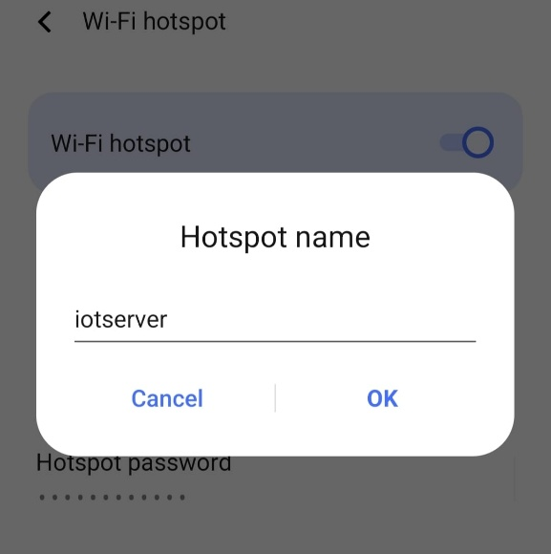

Figure 5.1 connecting to server.

5.2 Connecting the transmitter :

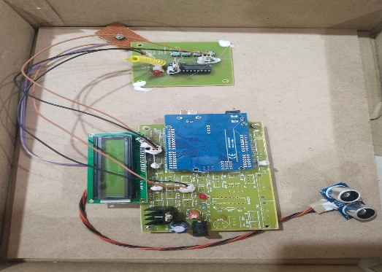
Figure 5.2: connecting the transmitter.

5.3 Connecting the reciever :

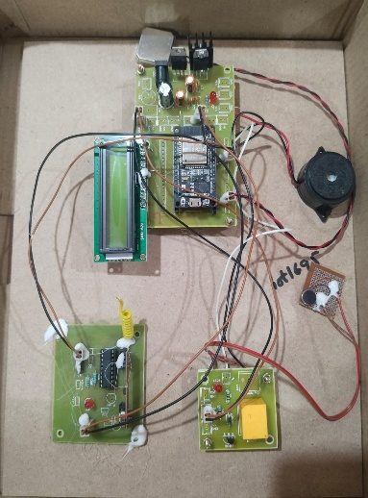
Figure 5.3: Connecting the receiver.

For Data, Search in projectfactoryserver.in:

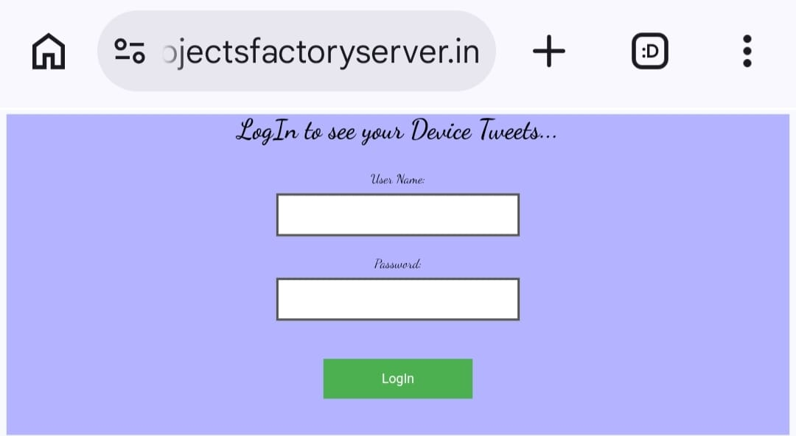
Figure 5.4: For Data, Search in projectfactoryserver.in

Display of data in the server:

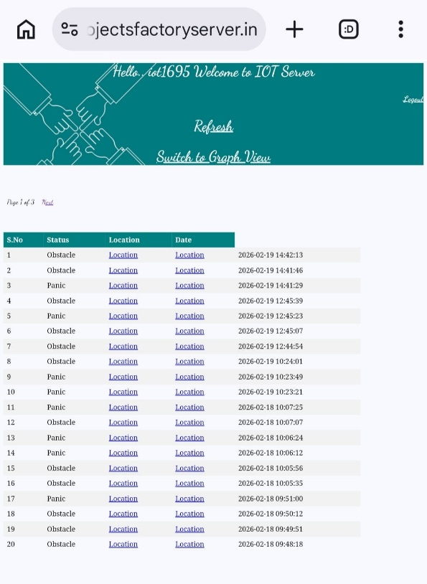
Figure 5.5: Display of data in the server

.VALIDATION

VALIDATION

The validation of this project primarily relies on extensive testing and well-defined test cases to ensure the accuracy and effectiveness of the inappropriate content detection system. The testing process involves multiple stages, including dataset validation, model performance evaluation, and real-world testing. By implementing a structured validation approach, we can ensure that the system consistently delivers high accuracy in detecting inappropriate content while minimizing false positives and false negatives.

INTRODUCTION

The validation phase of the Haptic Interface System for Disabled Individuals was carried out to
that all the components of the system operate correctly and perform their intended functions. During this stage, the complete hardware setup including the ESP8266 microcontroller, ultrasonic sensor, R.P.S module, GPS module, vibration motor, and buzzer was tested under different operating conditions. The aim was to confirm that the sensors accurately detect environmental inputs and that the processed information is correctly transmitted between the transmitter (TX) and receiver (RX) units. Several functional tests were conducted to check the responsiveness and coordination between the transmitter and receiver modules. The ultrasonic sensor was tested to verify its ability to detect obstacles at different distances, while the GPS module was examined to ensure accurate location tracking. The wireless communication between the ESP8266 modules was also evaluated to confirm reliable data transmission. In addition, the output devices such as the vibration motor and buzzer were tested to ensure that they provide timely alerts when obstacles are detected or when the emergency button is pressed.

6.2 TEST CASES

Test Case ID | Test Description | Input / Condition | Expected Result | Actual Result | Status
TC01 | Ultrasonic Sensor Obstacle Detection | Place an object within 50 cm of the sensor | Sensor detects obstacle and sends signal to microcontroller | Obstacle detected and signal processed correctly | Pass
TC02 | Distance-Based Alert | Object placed at different distances (20 cm, 40 cm, 80 cm) | System should trigger alerts depending on distance | Alerts triggered correctly according to distance | Pass
TC03 | Button Activation | Press the emergency button | Signal should be sent to the receiver and alert should be generated | Buzzer and vibration activated | Pass
TC04 | Wireless Communication | TX module sends data to RX module | RX module should receive signal without delay | Signal received and processed correctly | Pass
TC05 | Vibration Motor Feedback | Obstacle detected by ultrasonic sensor | Vibration motor should activate to notify the user | Vibration motor activated successfully | Pass
TC06 | Buzzer Alert | Obstacle or emergency signal triggered | Buzzer should produce alert sound | Buzzer produced sound alert | Pass
TC07 | GPS Location Tracking | Device powered on in open area | GPS should provide location data | Location successfully detected | Pass
TC08 | Mobile Communication | System connected to mobile device | Mobile device should receive transmitted data | Mobile received data successfully | Pass
TC09 | Continuous System Operation | System runs for extended time | System should operate without interruption | System worked continuously without errors | Pass
TC10 | Overall System Integration | All modules connected and running | System should detect obstacle and generate alert | System performed all operations successfully | Pass

.CONCLUSION & FUTURE ASPECTS

CONCLUSION & FUTURE ASPECTS
The Haptic Interface System for Disabled Individuals was developed to provide an assistive solution that helps users perceive their surroundings through tactile feedback. The system integrates ultrasonic sensors, a microcontroller, and vibration motors within a wearable device to detect obstacles and convert environmental information into vibration patterns. By providing real-time haptic alerts, the system enables disabled individuals to identify nearby obstacles and respond appropriately without relying on visual or auditory cues. This approach improves navigation safety and enhances user independence. The implementation and testing of the system demonstrated that the device successfully detects obstacles within a specified range and provides clear vibration feedback based on distance and direction. The wearable design makes the system comfortable for everyday use, while the use of cost-effective hardware components ensures affordability and accessibility. Overall, the project highlights the potential of haptic technology as a practical and efficient assistive solution for improving mobility and environmental awareness among disabled individuals.

PROJECT CONCLUSION

The main objective of this project was to design and implement a wearable haptic interface system capable of assisting disabled individuals in navigating their surroundings. The system utilizes ultrasonic sensors to detect obstacles and a microcontroller to process sensor data and generate appropriate vibration alerts through haptic actuators. The intensity and direction of the vibrations help users understand the proximity and location of obstacles, thereby improving their spatial awareness.
The results obtained during testing confirmed that the proposed system operates effectively and provides reliable tactile feedback in real time. The integration of sensors, embedded processing, and wearable design ensures ease of use and portability. The project demonstrates that a low-cost and energy-efficient haptic device can significantly enhance the independence and safety of disabled individuals during daily activities.

7.2 FUTURE ASPECTS

Although the proposed system performs its intended functions effectively, several improvements can be implemented in future versions to enhance its capabilities. Additional sensors such as infrared sensors, cameras, or LiDAR can be integrated to improve obstacle detection accuracy and provide more detailed environmental information. The inclusion of GPS technology could also enable outdoor navigation and route guidance for users.
Future developments may also focus on integrating artificial intelligence and machine learning algorithms to allow the system to recognize objects and adapt feedback patterns based on user behavior. Improvements in battery efficiency, miniaturization of hardware components, and the use of flexible wearable materials could further enhance comfort and usability. These advancements could transform the system into a more advanced and intelligent assistive device for disabled individuals.

BIBLIOGRAPHY

BIBLIOGRAPHY

REFERENCES

Human Haptic Perception, by Martin Grunwald, Birkhäuser Publishing, 2008.

Introduction to Autonomous Mobile Robots, by Roland Siegwart, Illah Nourbakhsh, and Davide Scaramuzza, MIT Press, 2011.

Arduino IDE Documentation – https://www.arduino.cc/reference

ESP8266 Arduino Core Documentation – https://arduino-esp8266.readthedocs.io

ESP8266 Wi-Fi Module Technical Datasheet – Espressif Systems.

HC-SR04 Ultrasonic Sensor Datasheet – Distance Measuring Sensor Module.

**IEEE Digital Library – Research papers on Haptic Interfaces and Assistive Technologies.

World Health Organization reports on assistive technologies and disability support.

GITHUB LINK

https://github.com/abbu10101-design/HAPTIC-INTERFACE-SYSTEM-FOR-THE-DISABLED-INDIVIDUALS-

